AWS Systems Manager Parameter Store.

Task :Create a parameter and access via ec2.
Objective
To securely store application configuration or secrets in AWS Systems Manager Parameter Store and retrieve them from an EC2 instance using an IAM role, avoiding hardcoding sensitive data.
Prerequisites
- AWS account
- An EC2 instance running (Amazon Linux/Ubuntu)
- IAM role attached to EC2 with permissions:
  - ssm:GetParameter
  - ssm:GetParameters
  - kms:Decrypt (if using SecureString)
- AWS CLI installed and configured on EC2
- A parameter created in Parameter Store (String or SecureString)
- Network access to AWS SSM endpoints (internet/NAT or VPC endpoints)

Step by Step Implementation:

Navigate to Parameter store on aws and click on create parameter
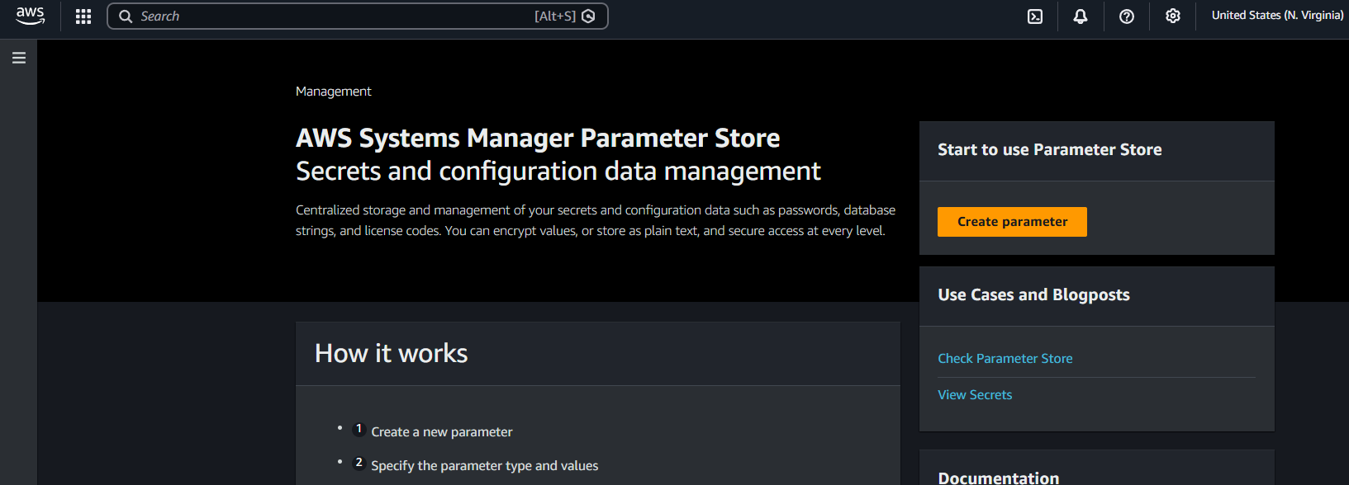
Provide the parameter name and select the TIER
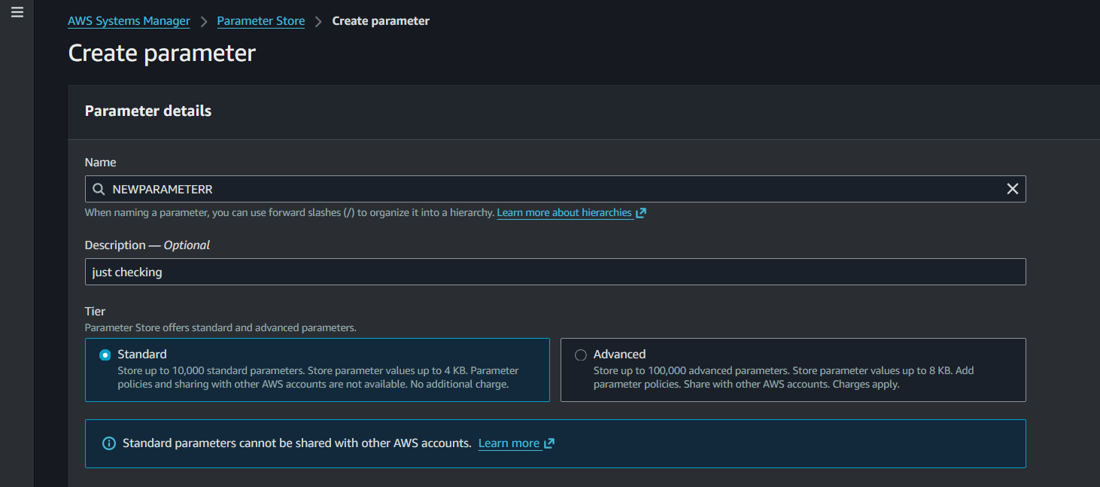

Select the STRING and Enter the Value means secret value and click on create parameter
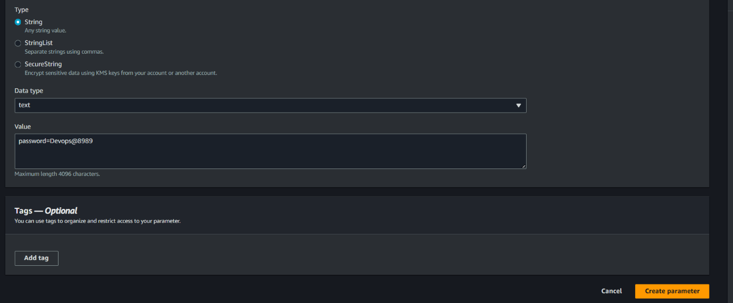
New parameter had been created
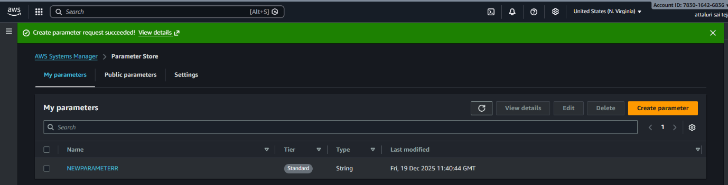
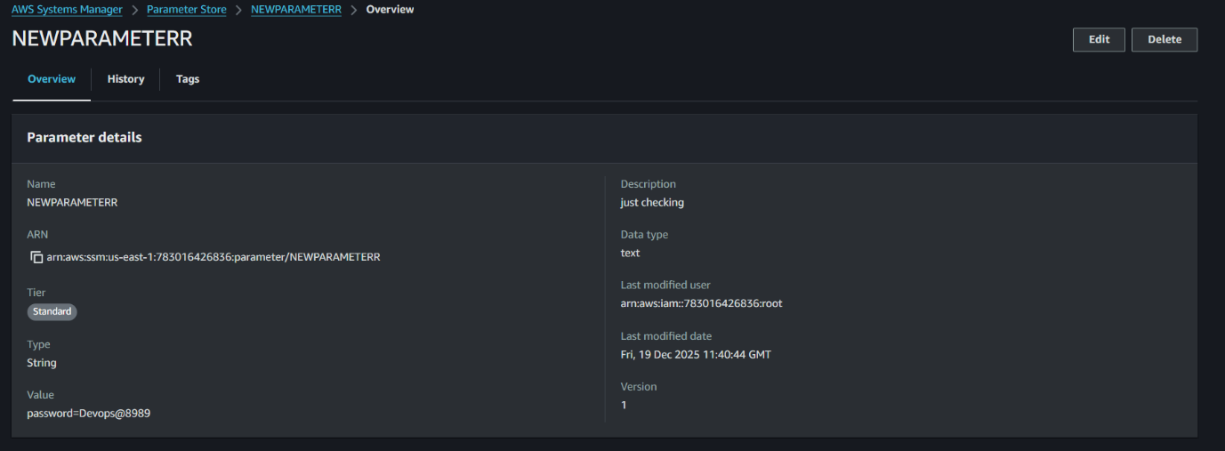
Checking the versions and its only one because we didn’t made any changes
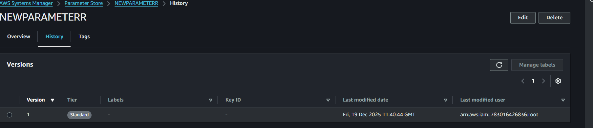

And made changes in the password using edit options and reverified and versions are available in two.
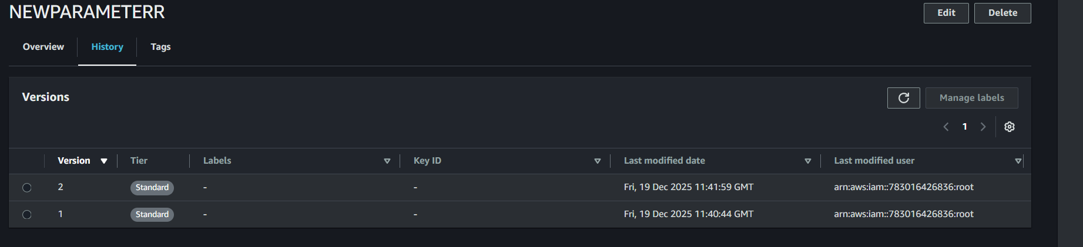
Create a IAM role and attach it to EC2
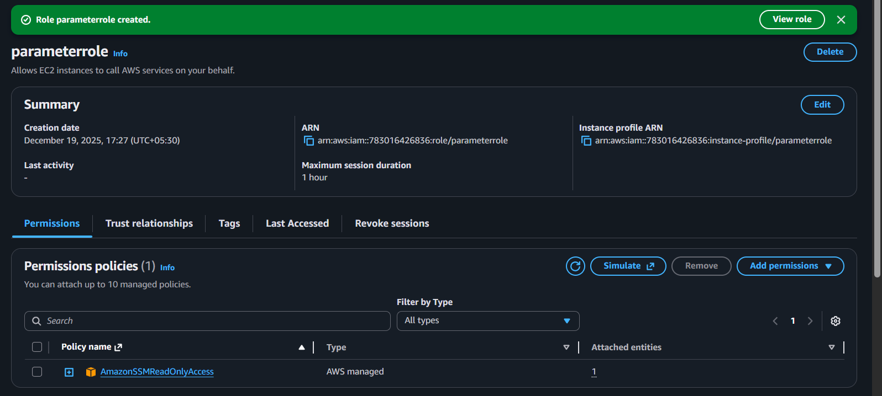
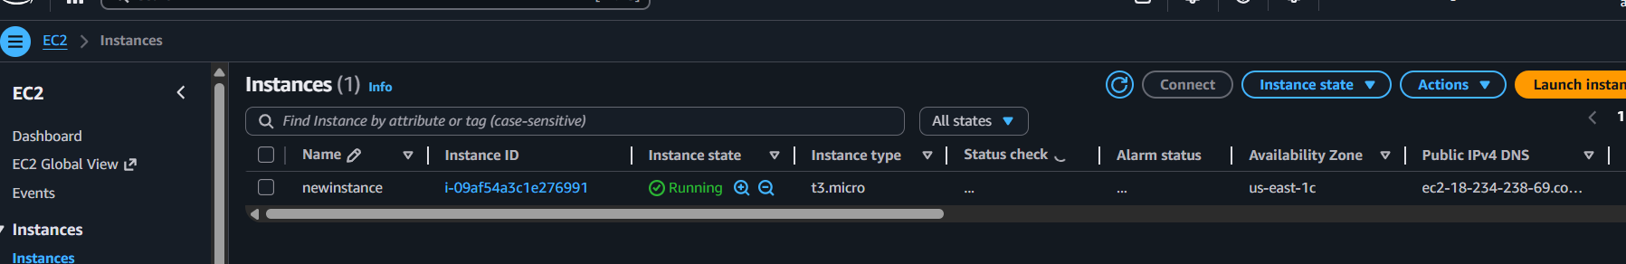
Role has been attached to EC2
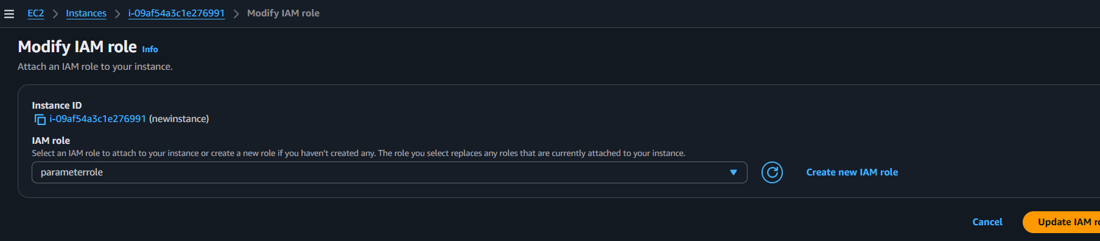

Validation Part::
Connect EC2 via SSH or in browser
Command::: for only Value
aws ssm get-parameter \
--name "NEWPARAMETERR" \
--query "Parameter.Value" \
--output text
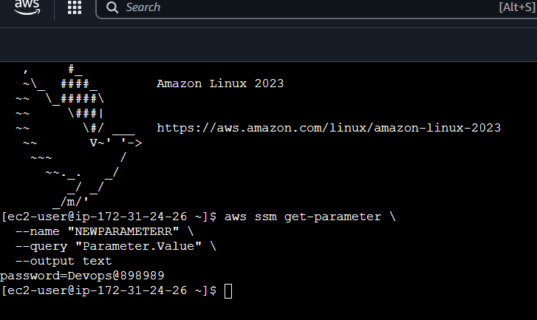
If you want to fetch multiple parameters by path
aws ssm get-parameters-by-path \
--path "/" \
--recursive \
--with-decryption \
--query "Parameters[].{Name:Name,Value:Value}"
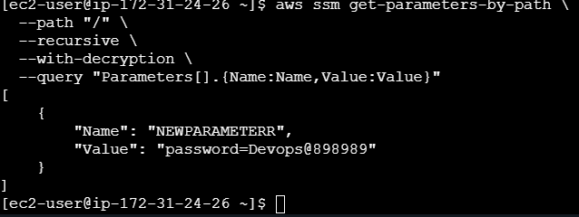

Conclusion
Using SSM Parameter Store with EC2 enables secure and centralized configuration management. It improves security by eliminating hardcoded secrets and simplifies parameter updates without redeploying applications.

